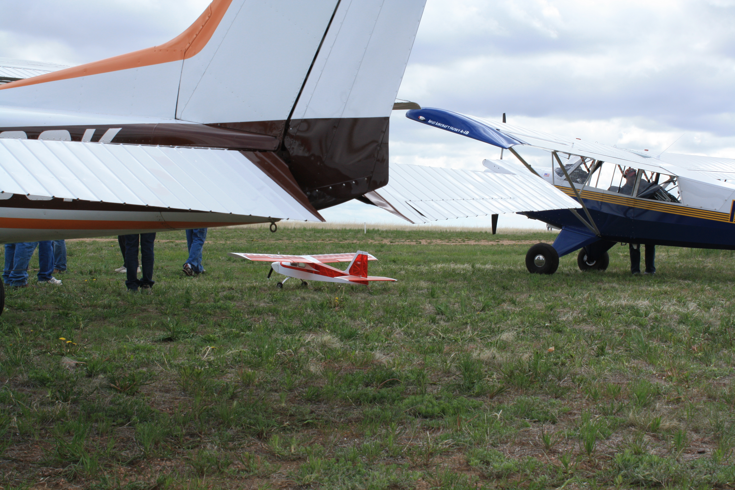
Fourth ANNUAL MEMORIAL DAY FLY-IN
You can drive in also
DATE: May 28th. 2012 MONDAY
TIME: 0700-1000
LOCATION: 1CD1 Reed Field (104.52.06W, 40.41.43 N) E-mail for driving directions.
Field Elevation: 5350’
CTAF: 122.85
Preferred Landing to the NW, Takeoff SE

WE PROVIDE: Coffee (on @ 0700) Water, Juice, Pancakes, and Sausage provided (@0800)

You Bring: Tie Downs, Chairs, Angie says no-one should bring food. We will have plenty

Kids and Families welcome.

If you want to participate in the bomb drop, take TWO styrofoam cups, fill with flour, tape together. Bring the fun, I supply the targets.

RSVP: 970-897-3066, rreed@fcgov.com, 4reed@ezlink.com with numbers attending so we can have enough food.

If you have not flown into Reed Field before, there are power lines at the end of the runway at the northwest end, and the runway slopes uphill SE to NW.

Cancellation will be made by 2000 hours on May 27th, due to weather. If you send your RSVP by email, I will cancel by emails by 2000 on May 27th.

Hope to see you here. Russ

